Supplementary Material for: “On-chip metamaterial-enabled high-order mode-division multiplexing”

Yu He,ª Xingfeng Li,ª Yong Zhang,ª Shaohua An,ª Hongwei Wang,ª Zhen Wang,ª Haoshuo Chen,^{b} Yetian Huang,^{c} Hanzi Huang,^{c} Nicolas K. Fontaine,^{b} Roland Ryf,^{b} Yuhan Du,ª Lu Sun,ª Xingchen Ji,^{d} Xuhan Guo,ª Yingxiong Song,^{c} Qianwu Zhang,^{c} Yikai Su^{a,*}
a State Key Lab of Advanced Optical Communication Systems and Networks, Department of Electronic Engineering, Shanghai Jiao Tong University, Shanghai, China, 200240
b Nokia Bell Labs, 600 Mountain Ave, Murray Hill, NJ, USA, 07974
c Key Laboratory of Specialty Fiber Optics and Optical Access Networks, Joint International Research Laboratory of Specialty Fiber Optics and Advanced Communication, Shanghai University, Shanghai, China, 200444
d John Hopcroft Center for Computer Science, School of Electronic Information and Electrical Engineering, Shanghai Jiao Tong University, Shanghai, China, 200240

This document provides supplementary information to “On-chip metamaterial-enabled high-order mode-division multiplexing”. In Section 1, we show a description of the effective-medium theory employed for the design and analysis of the GIM structure. Section 2 describes the coupling process of the GIM-based coupler. Section 3 shows the detailed simulated results for the 16-channel MDM device. Section 4 and 5 provide the experimental setup for the high-speed data transmission experiments and the DSP flow chart for the employed MIMO algorithm.

*Yikai Su, E-mail: yikaisu@sjtu.edu.cn

1 Effective-medium theory for gradient index metamaterial (GIM) waveguide
The effective refractive index of the GIM waveguide is calculated by using the effective-medium theory. For a conventional one-dimensional periodic structure with a period much smaller than the wavelength of the light (Λ << λ / 2), the guiding wave can be confined within the grating structure rather than being diffracted or scattered. The grating acts as a homogeneous medium with an effective refractive index of:
, (S1)
where n_{Si} and n_{clad} are the refractive indices of silicon (n_{Si} = 3.47) and SiO₂ (n_{clad} = 1.46), respectively. η is the duty cycle of the periodic structure which can be defined as:
, (S2)
with a being the width of the silicon nano-pillar and Λ being the period of the grating structure. By using the effective-medium approach, the periodic structure can be approximated to a homogeneous medium with a tailorable refractive index, as shown in Fig. S1(a). Thus, it is viable to calculate the supported eigen modes and the corresponding effective indices of the periodic grating structure through the finite-difference eigenmode (FDE) solver.
In this paper, we design a GIM waveguide with its duty cycle (a(z) / Λ) varies along the propagation direction. According to the effective-medium theory, it can be regarded as a strip waveguide with a linearly varied refractive index along the propagation direction, as shown in Fig. S1(b). The duty cycle η of the GIM waveguide is chosen as 70% and 30% at the beginning and the end of the GIM waveguide, respectively, by considering the fabrication feasibility. We calculate n_{eq} using Eq. (1) and the effective refractive index of the supported Bloch mode using an FDE solver, as shown in Fig. S1(d). The spatially varied distribution of silicon contributes to the linear decrease of n_{eff}, which further introduces a new physical dimension for engineering the coupling coefficient between waveguides.
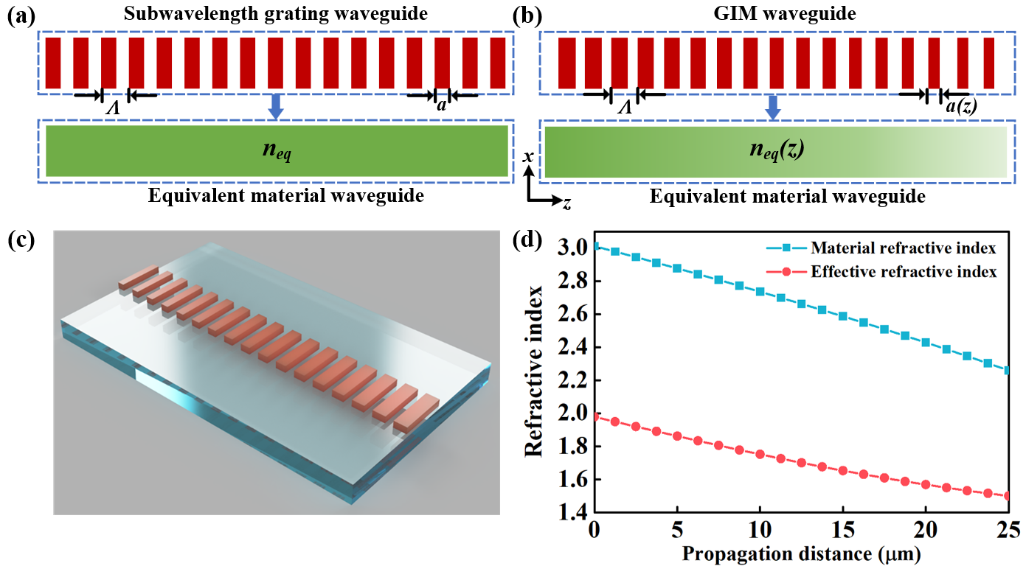
Fig. S1. Effective medium theory for periodic grating structure. a, Schematic configuration of the subwavelength grating. b, Schematic configuration of the GIM waveguide. c, 3D illustration of the GIM waveguide sitting on a SiO₂ bottom cladding. d, Calculated refractive indices of the equivalent materials for GIM waveguides with different duty cycles and calculated n_{eff} of the supported Bloch mode.
The n_{eff} of a periodic structure can also be derived by calculating the bandgap diagram. Here we plot the bandgap diagrams obtained by using COMSOL Multiphysics for GIM waveguides with 30%, 40%, 50% 60% and 70% duty cycles, respectively. The red circles highlight the supported fundamental modes at the frequency of 1.93 THz (1550 nm). We calculate n_{eff} of the supported Bloch modes as shown in Fig. S2(d). It is noteworthy that the n_{eff} values of the Bloch modes match well with the n_{eff} values obtained by using the effective-medium theory, indicating the feasibility of using the effective-medium theory to estimate the n_{eff} of the GIM waveguide. This method is useful when the period of the device is smaller than λ/4, in which case the light can not feel the discontinuity of the GIM waveguide. And the GIM structure can be regarded as a homogeneous medium with a lower refractive index. This approach has been widely utilized in various research papers as well³⁹⁻⁴¹.
Fig. S2. Calculated bandgap diagrams for GIM waveguides with the duty cycle of, a, 30%, b, 50%, c, 70%. d, Comparison of the n_{eff} calculated using two different approaches.

2 Calculation of coupling coefficients for GIM-based coupler
Figure S3(a) shows a GIM waveguide-based directional coupler. Since the equivalent refractive index of the GIM is varied, the coupling coefficients are also changed with regards to the duty cycle variation along the propagation direction. We calculate the coupling coefficients of the GIM-based coupler using coupled mode theory. For the coupling of rectangular waveguides, the coupling coefficients can be written as:
, (S3)
, (S4)
where E_{a}(x,y) and E_{b}(x,y) are the electric field distributions of the waveguide modes a and b, respectively. S is the cross section of the GIM-based coupler and Δn(x,y,z) is the refractive index contrast between the silicon core and the equivalent material of the GIM waveguide. In most of the conventional analyses, reciprocity of the coupling coefficients is satisfied for a conventional directional coupler. However, due to the nonuniform distribution of the refractive index induced by the GIM waveguide, we should consider the nonreciprocity of the coupling coefficients and calculate κ_{ab} and κ_{ba} respectively.
Firstly, we calculate the electric field distributions of the target modes (Bloch mode in GIM waveguide and TE₅ mode in the silicon strip waveguide in this case) using a FDE solver. We simulate the mode distributions at the cross section of the GIM-based coupler as shown in Figs. S3 (a-b), for GIM waveguide and strip waveguide, respectively. The dimension of the simulation window is chosen as 5.0 × 2.0 μm² with a mesh size of 10 nm in both directions. Figs. S3 (c-d) show the calculated mode electric field distributions for selected waveguide modes. Then the calculated data is exported as a Matlab data file, which includes the electric field distributions and the refractive index distributions within the simulation region. Here the
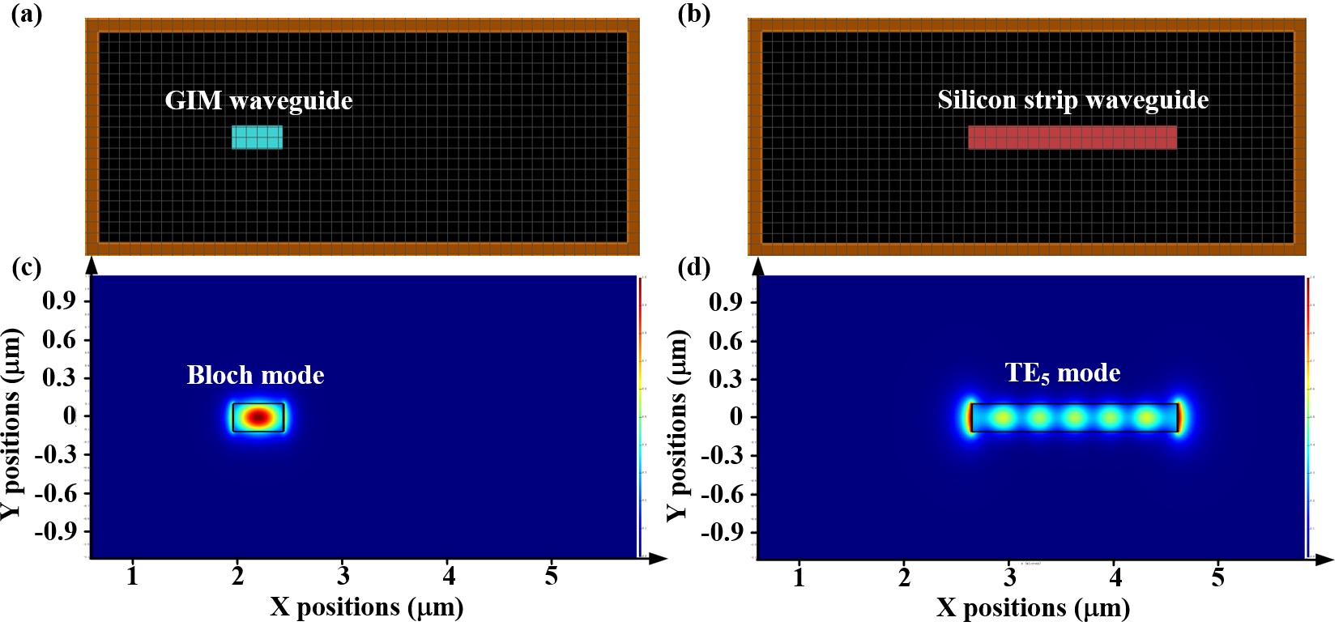
Fig. S3. Calculation of the electric field distributions using FDE method. a, Simulation window of the GIM waveguide. Here the periodic GIM structure is replaced by an effective medium as discussed in S1. b, Simulation window of the silicon strip waveguide. c, Calculated electric field distribution in the GIM waveguide. d, Calculated electric field distribution of TE₅ mode in the GIM waveguide.
equivalent material refractive index of the GIM waveguide is calculated by referring to the Supplementary Section 1 part.
By using this method, we can calculate the coupling coefficient at selected z positions of the GIM coupler using Eqs. (S3) and (S4) as shown in Fig. S4 (b). It can be noted that the coupling coefficients κ_{ab} and κ_{ba} linearly vary as a function of the duty cycle of the GIM waveguide. There are two factors that may contribute to the modulation of the coupling coefficients: 1) The refractive index contrast between the GIM waveguide and the SiO₂ cladding. Since the GIM waveguide can be approximated to a dielectric waveguide with a varied refractive index, Δn(x, y, z) also varies along the propagation direction, which leads to the modulation of the coupling coefficient; 2) The field distributions of the GIM-based coupler. Fig. S4(a) shows the cross-section view of the GIM-based coupler and the illustration of the electric field intensity distributions. For a GIM waveguide with a large duty cycle (e.g. 70%), the electric field is well confined within the GIM waveguide due to the large refractive index of the equivalent material. On the contrary, the electric field is less confined for a small duty cycle (e.g. 30%). The variation of the electric field distributions induced by the GIM waveguide further leads to the modulation of the coupling coefficient along the propagation direction. These two factors jointly contribute to the efficient coupling coefficient modulation, which is challenging for conventional directional couplers.
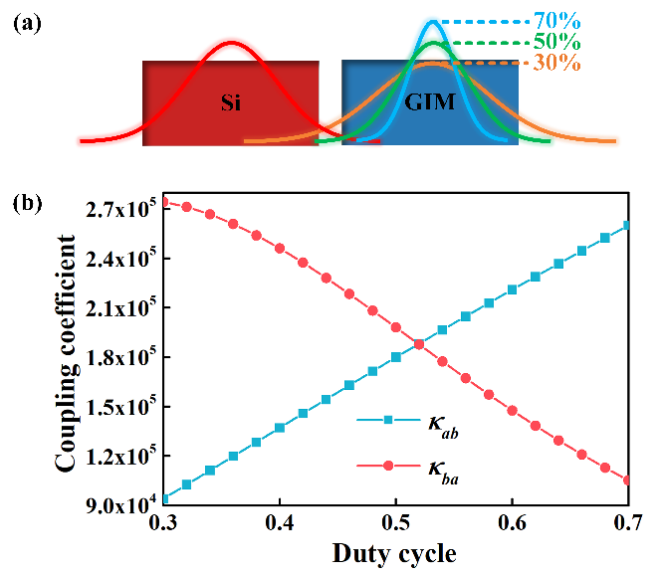
Fig. S4. Coupling coefficients calculation of the GIM-based coupler a, Cross-section view of the GIM-based coupler and the illustration of the electric field intensity distributions. b, Calculated coupling coefficients as a function of duty cycle.
Furthermore, we calculate the coupling efficiency of the two modes between the GIM waveguide and the silicon strip waveguide. The mode coupling equations can be written as:
, (S5)
, (S6)
By integrating Eqs. (S5) and (S6) using trapezoidal rule, we can calculate the amplitudes as well as the intensities of the two waves as a function of propagation distance, as shown in Fig. S5.
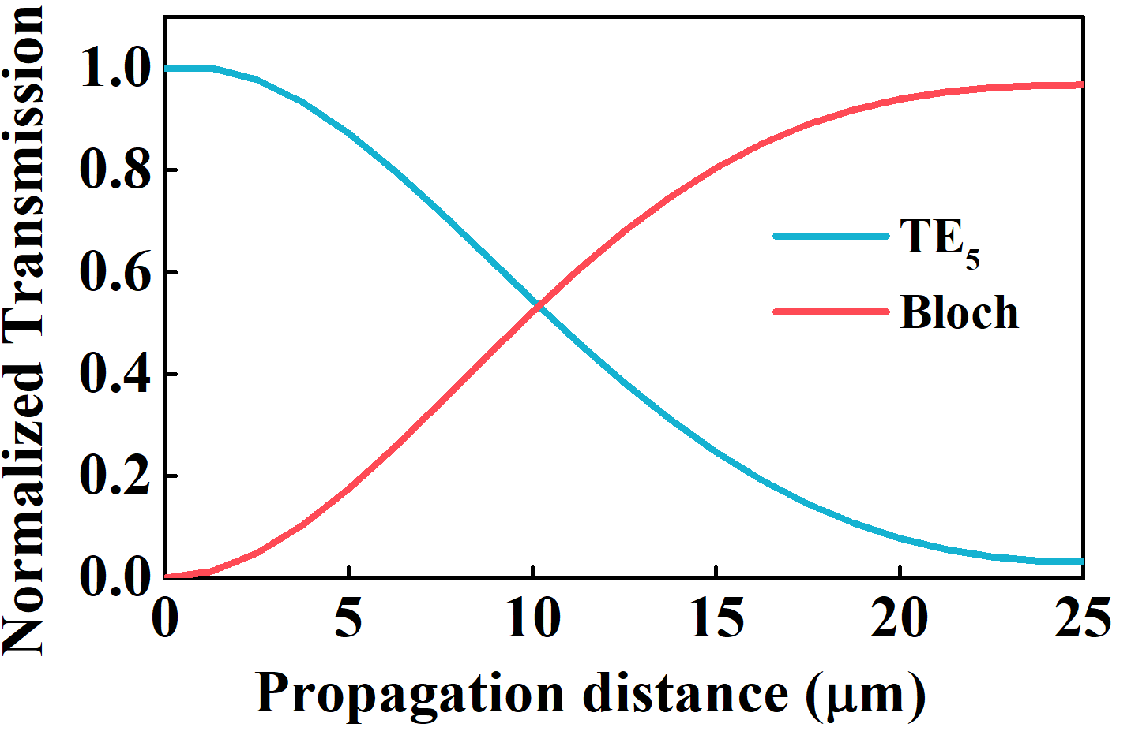
Fig. S5. Calculated mode coupling process with respect to the propagation distance.

3 Simulations and optimizations of the GIM-based mode (de)MUX
We simulate the performance of the GIM-based mode (de)MUX using 3D-Finite Difference Time Domain (FDTD) method (ANSYS Lumerical). We consider the mode demultiplexing process by injecting a high-order mode from the bus waveguide and monitoring the output from the output port of the GIM waveguide. The simulation window dimension is 31.0 × 8.5 μm² with a mesh size of 10 nm in both directions. We choose perfectly matched layers (PMLs) as boundary conditions to avoid the undesired backscattering. Simulated power distributions for TE₁ ~ TE₁₅ demultiplexing processes are provided in Fig. S6. It can be noted that the injected high-order modes are efficiently coupled to the GIM waveguide and converted to fundamental modes simultaneously.
In the simulation process, we optimize the performances of the GIM-based couplers for different modes by sweeping the width of the silicon bus waveguide to get a maximum output power. The optimized bus waveguide widths are 0.83、1.05、1.43、1.76、2.09、2.45、2.75、3.14、3.53、3.88、4.22、4.56、4.83、5.17、5.62 μm for TE₁ ~ TE₁₅ modes, respectively.
Fig. S6. Simulated electric field distributions for TE₁ ~ TE₁₅ demultiplexing processes.

4 Experimental setup for the 16-channel MDM chip characterization
Fig. S7 shows the experimental setup for the 16-channel MDM chip characterization. We employ 16 polarization controllers to adjust the polarization states of the input signals before entering the silicon chip. Grating couplers are employed to couple signals in and out of the chip, as shown in the insets of Fig. S7. We use a six-axis stage to align the fiber array and the silicon chip with a coupling loss of ~ 6.5 dB/facet. After the on-chip multiplexing, multimode transmission and demultiplexing processes, 16 channels are coupled out and combined by using 8 polarization beam combiners (PBCs), as shown in Fig. S7. We use 16 PCs to align the polarization states of the neighbouring channels to ensure a maximum received optical power at the receiver. Eight fiber delay lines are employed to recombine the 8 channels chronologically to 8 time slots.
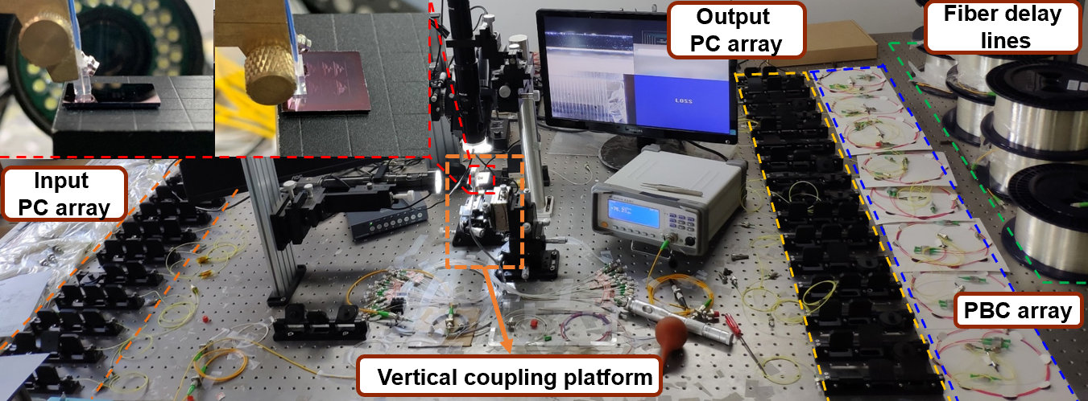
Fig. S7. Experimental setup for the 16-channel MDM chip characterization.

5 MIMO-based DSP algorithm
The DSP flow charts for the transmitter side and the receiver side are shown in Figs. S8(a-b), respectively. At the transmitter-side DSP, a square-root raised cosine filter with a roll-off factor of 0.01 is employed to generate a Nyquist-shaped 16-QAM signal. At the receiver-side DSP, the time-division multiplexing signals are sliced to acquire the signal carried by each mode. We employ multiple-input multiple-output (MIMO)-based digital signal processing (DSP) to tackle the mode mixing and recovers the transmitted information streams. The 16-QAM data is recovered utilizing a 16×16 multiple-input multiple-output feedforward equalizer (MIMO-FFE) with 38 taps employing data-aided least-mean-square algorithm, which is operated at data-aided mode and switched into decision-directed mode after training data is exhausted. Besides, a 2-tap post-filter and a maximum-likelihood sequence decision (MLSD) are implemented to mitigate the influence of the noise enhancement effect of the FFE.
Fig. S8. DSP flow charts for high-speed transmission. a, Transmitter side. b, Receiver side. MIMO-FFE is employed to mitigate the crosstalk imposed on signal channels.

